

**Tribhuvan University**

**Faculty of Humanities and Social Sciences**

**“Music On: Music Streaming Web App”**

**A PROJECT PROPOSAL**

**Submitted to**

**Department of Computer Application**

**Kathmandu Business Campus**

Banasthali, Kathmandu

***In partial fulfillment of the requirements for the Bachelor in Computer Application***

**Submitted by**

**Rikin Tuladhar**

**University SN: 6-2-1219-21-2020**

BCA 6th Semester

Under the Supervision of

Table of Content

1. Introduction 1

2. Problem Statement 1

3. Objectives 1

4. Methodology 2

4.1 Requirement Identification 3

4.1.1 Study of existing system 3

4.1.2 Requirement Collection 3

4.2 Feasibility Study 4

4.3 High Level Design of System 5

4.3.1 System Flow Chart 5

4.3.2 Context Level Diagram 5

4.3.3 Entity Relationship Diagram 6

5. Gantt Chart (Project Schedule) 6

6. Expected Outcomes 7

7. References 7

# Introduction

In today's digital age, music streaming apps have become the dominant force in music consumption. These services offer unparalleled convenience, allowing users to access vast libraries of licensed music on-demand from any internet-connected device. Gone are the days of bulky MP3 players and meticulously curated playlists; millions of songs are now at your fingertips, ready to be streamed whenever you desire.

Music On is a web-based application that provides music services, allowing users to listen to songs categorized by artist, library, or genre. This platform enhances the music listening experience by offering a diverse selection of tracks and easy navigation through various musical categories. It features a recommendation system that suggests songs users might enjoy, enhancing their listening experience by tailoring selections to their tastes.

Overall, Music On offers features like song playback, lyrics, and search capabilities, making it highly appealing to users.

# Problem Statement

In the digital age, users seek a comprehensive and seamless music streaming experience that goes beyond just listening to songs. They desire a platform that not only provides a vast library of music but also offers personalized recommendations, accurate lyrics, and efficient search capabilities. Existing music streaming services often lack an integrated approach to combining these features in a user-friendly manner.

# Objectives

* Provide personalized song recommendations to enhance the user experience.
* Enhance the listening experience by providing lyrics for songs.
* Offer users an online music streaming service.

# Methodology

The waterfall model is a classical model used in the system development life cycle to create a system with a linear and sequential approach. It is termed a waterfall because the model develops systematically from one phase to another in a downward fashion. The waterfall approach does not define the process to go back to the previous phase to handle changes in requirements . The waterfall approach is the earliest approach that was used for software development.

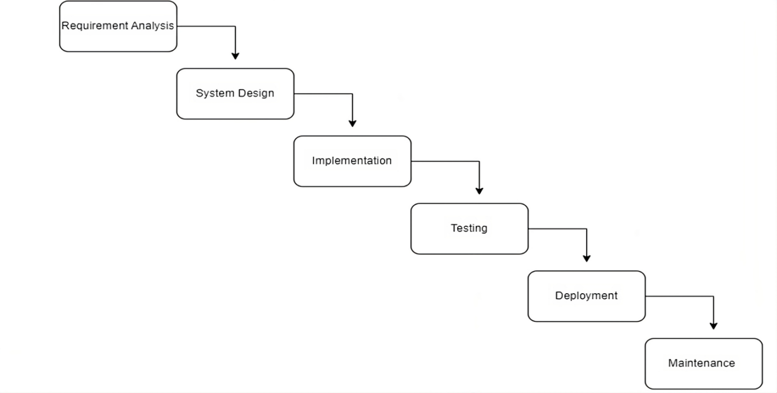

Fig 1-Waterfall model

Overall, the waterfall model provides a structured approach to the development of an employee work tracking website. It ensure that all necessary phases are completed before moving on to next, reducing the risk of errors and ensuring that the final product meets the need of end-users.

### **4.1 Requirement Identification**

### 4.1.1 Study of existing system

In this project, I conducted extensive research on various music streaming platforms, including Spotify, Apple Music, Amazon Music, and YouTube Music. Through this analysis, I identified common trends and issues prevalent across these services. A significant challenge faced by most music streaming platforms is the limited features offered to users on their free tiers. These limitations often manifest as lower audio quality, frequent advertisements, device restrictions, and complicated navigation systems. Free-tier users typically experience inferior audio quality compared to premium subscribers, with services like Spotify and YouTube Music relying heavily on ads to monetize their free users. Moreover, some platforms are optimized for specific devices or ecosystems, like Apple Music, potentially alienating users on other platforms. The complex interfaces of these apps often deter users from fully exploring their features and discovering new content.

In contrast, my proposed system aims to address these limitations by offering high-quality audio, an ad-free experience, song lyrics, personalized recommendations, and the ability to save playlists.

### 4.1.2 Requirement Collection

Requirement collection and analysis are crucial steps in the system development process. Before implementing a system, it is essential to thoroughly understand and document its requirements. This process involves identifying and specifying the needs and constraints of various stakeholders. Requirements are typically categorized into two main types:

**Functional Requirements:**

These define the specific behaviors or functions of the system. They describe what the system should do, such as tasks, services, or functions the system must perform.

**Non-Functional Requirements:**

These define the system's quality attributes, constraints, and performance criteria. They describe how the system performs its functions, including aspects like usability, reliability, performance, and security.

## 4.2 Feasibility Study

A feasibility study is an analysis that consider all the project’s affecting factors like economic, technical, legal and scheduling considerations.

* Technical Feasibility

To design this system, we will be using existing technologies, software and hardware so there is no technological hurdle to build this system

* Operational Feasibility

These include reliability, maintainability, usability, support ability. The proposed system is operationally feasible as it is reliable for all types of users i.e whether the user has knowledge of a computer or not. The proposed system is supported for a small to large- scale organization. It is simple and easy to use due to its simple user interface and operational feasible.

**Tools :**

Front-end:

- HTML

- CSS

- JavaScript

- Tailwind

- React

Back-end:

- JAVA

- Spring Boot

- MySQL

## 4.3 High Level Design of System

### 4.3.1 System Flow Chart

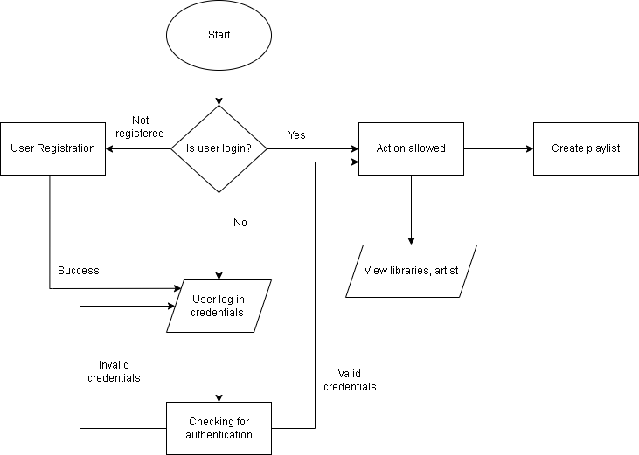

**Fig:2 Flow chart diagram**

### 4.3.2 Context Level Diagram

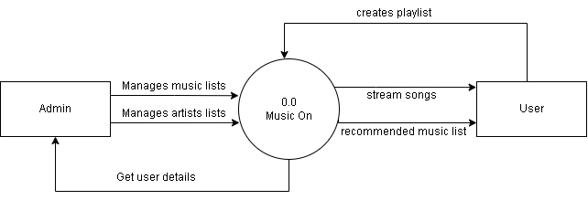

**Fig:3 Context level diagram**

4.3.3 Entity Relationship Diagram  
 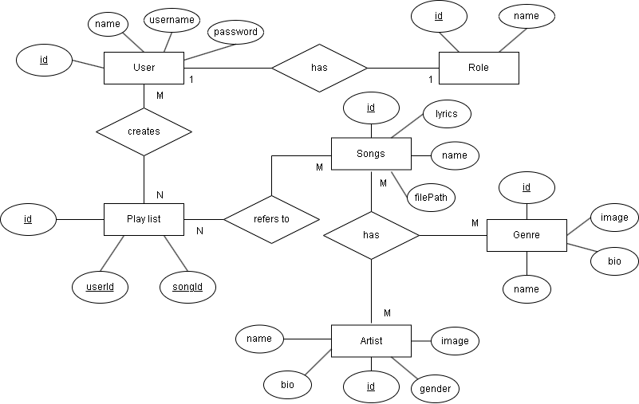

**Fig:4 ER diagram**

# Gantt Chart (Project Schedule)

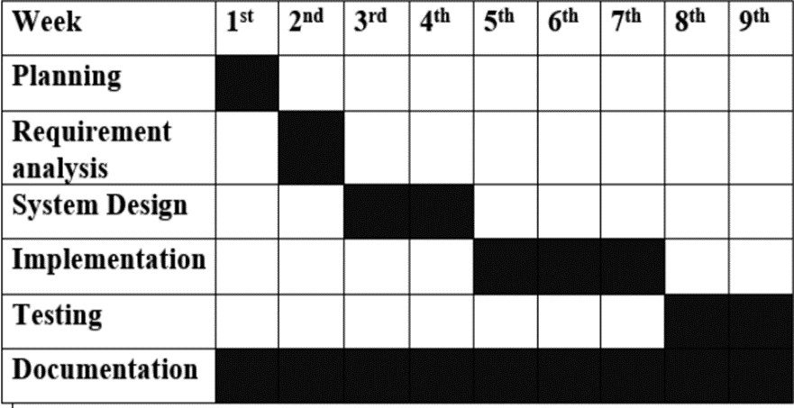

**Fig:5 Gantt Chart**

# Expected Outcomes

After the system is completed within the scheduled time, users will be able to register and login to the system and take advantage of the system’s features like personalized recommendation, access song lyrics, making music listening more engaging and enjoyable. The platform aims to provide high-quality audio and an ad-free listening experience, distinguishing itself from many free-tier service offered by existing platforms.

"Music On" will offer a comprehensive music library with songs categorized by artist, genre, or library, facilitating easy navigation and exploration. The platform's intuitive and user-friendly interface will encourage users to discover new content without the complexity found in many existing services. Additionally, the service will be accessible on multiple devices, including smartphones, tablets, and desktops, ensuring convenience and flexibility in how users listen to music.

# References

1. [Music Streaming App Project Report | Download Free PDF | Software Testing | Software (scribd.com)](https://www.scribd.com/document/618932599/music-streaming-app-project-report)
2. [Create Your own Music Streaming App: Step by Step Guide (a3logics.com)](https://www.a3logics.com/blog/step-by-step-guide-to-creating-your-own-music-streaming-app/)